|  |
| --- |
|  |
| **Nutrition and Physiotherapy Clinic Management System**  Dr. Sahar Fawzi  Eng. Malak Soliman |
| |  |  |  | | --- | --- | --- | | BMD302: Clinical Informatics | FALL23 | TECHCARE | |

Table of contents

***Abstract-----------------------------------------------------------------------------------------------02***

1. ***Introduction--------------------------------------------------------------------------03***

***1.1 Problem Definition---------------------------------------------------04***

***1.2 Purpose---------------------------------------------------------------05***

***2. Methodology--------------------------------------------------------------------------06***

***3. Results& Discussion---------------------------------------------------------------10***

***4. Conclusion----------------------------------------------------------------------------16***

***5. Acknowledgments-----------------------------------------------------------16***

***6. Future Plan & Suggestions -----------------------------------------------17***

***7. References-----------------------------------------------------------------18***

**Abstract**

In today's rapidly evolving healthcare landscape, the integration of nutrition and physiotherapy plays a pivotal role in holistic patient care. However, managing the diverse needs of patients in these fields can be complex and time-consuming. To address this challenge, we present an innovative Nutrition and Physiotherapy Clinic Management System designed to streamline clinic operations and enhance patient outcomes.

Our primary objective is to automate the myriad tasks involved in managing a nutrition and physiotherapy clinic, reducing administrative burden and improving overall efficiency. This comprehensive solution encompasses a robust backend database design seamlessly integrated with a user-friendly front-end desktop application.

***Key Components:***

Backend Database Design: Our backend model encompasses essential entities such as Dashboards, Healthcare Professionals, Patients, and administrative functions, ensuring comprehensive data management.

Frontend Desktop Application: The frontend application provides an intuitive interface for healthcare professionals to manage patient appointments, treatment plans, and progress tracking seamlessly.

Integrated Nutrition and Physiotherapy Operations: The system supports the unique operational needs of nutrition and physiotherapy clinics, facilitating seamless coordination between healthcare providers and patients.

Enhanced Patient Experience: Patients benefit from a streamlined appointment scheduling process, personalized treatment plans, and convenient access to their health records through the patient portal.

Administrative Capabilities: Administrators have access to powerful tools for managing clinic resources, generating reports, and analyzing clinic performance metrics.

Secure Data Management: Leveraging robust security measures, including encrypted data transmission and access controls, we ensure the confidentiality and integrity of patient information.

Our project aims to revolutionize the delivery of healthcare services in the nutrition and physiotherapy domain by combining advanced technology with user-centric design principles. By empowering healthcare professionals and enhancing patient experiences, we strive to advance the standard of care in this vital area of healthcare.

1. **Introduction**

Your body's well-being hinges on various factors, including nutrition and physical fitness. Nutrition fuels your body, providing the essential nutrients needed for optimal function, while physiotherapy enhances mobility and promotes recovery from injury or illness. Together, they form the cornerstone of a healthy lifestyle.

In today's world, where sedentary lifestyles and processed foods are prevalent, the importance of nutrition and physiotherapy has never been clearer. As our understanding of these fields evolves, so does the need for comprehensive care and accurate record-keeping.

Patients often seek guidance from healthcare professionals in managing their dietary habits and addressing physical ailments. However, practitioners may face challenges in recalling past cases and staying abreast of the latest advancements in nutrition and physiotherapy.

Regular consultations and assessments play a crucial role in identifying nutritional deficiencies, devising personalized diet plans, and prescribing tailored exercise routines. These interventions not only promote physical health but also contribute to overall well-being and quality of life.

By implementing robust management systems and prioritizing meticulous documentation of patient data, we aim to streamline the delivery of nutrition and physiotherapy services. Through integrated approaches and continuous education, we aspire to empower both patients and practitioners in achieving optimal health outcomes and fostering a culture of wellness.

***1.1 Problem Definition:***

The Nutrition and Physiotherapy Clinic Management System may encounter challenges related to data management and appointment scheduling. To address these issues, we aim to leverage computer technology and database storage to securely store patient information. Storing patient data in a centralized database enables easy retrieval for future reference and facilitates informed decision-making during diagnosis and treatment planning.

Furthermore, analyzing patient data allows us to identify trends, patterns, and potential risk factors, leading to more accurate diagnoses and personalized treatment plans. By maintaining an up-to-date management system, we can stay informed about advancements in nutrition and physiotherapy, ensuring that our practice remains current and effective.

***1.2 Purpose:***

Our goal is to develop a comprehensive management system tailored for nutrition and physiotherapy clinics, aimed at enhancing efficiency for both patients and healthcare providers. The primary objective is to streamline clinic operations by automating administrative tasks and facilitating seamless data management.

To achieve this, we will create a fully functional desktop application with a robust backend database infrastructure. We will present a polished and complete application to clinic executives, showcasing features such as a customizable dashboard, user-friendly interfaces for doctors and patients, and a secure login system.

The application will support essential clinic operations, including appointment scheduling, patient record management, and treatment planning. Administrators will have the ability to oversee and manage the system, with features for adding new data, generating reports, and monitoring clinic activities.

Overall, our purpose is to develop a tailored solution that optimizes clinic workflows, enhances patient care, and empowers healthcare providers with efficient tools for delivering nutrition and physiotherapy services.

1. **Methodology**

Our methodology encompasses six phases aimed at developing a robust nutrition and physiotherapy clinic management system:

2.1 Study Design: We began with a retrospective study of various cases in nutrition and physiotherapy clinics. By analyzing patient data, we aimed to identify effective methods for detecting specific conditions and staying updated on new diseases and treatments in the field.

2.2 Data Gathering: Recognizing the importance of data management, we employed computers and databases to store patient information securely. This facilitated efficient decision-making and appointment management. Storing all entered data allowed for accurate diagnoses and treatment planning.

2.3 Front-end Phase: The front end of our system was designed to support user operations such as viewing dashboards, logging in, managing appointments, accessing nutrition and physiotherapy departments, and generating reports. The interface was user-friendly and intuitive, guiding users through application functionality.

2.4 Back-end Phase: We provided a comprehensive database design to serve as the backbone of the system. Recognizing the challenge physicians face in recalling past diagnoses, we aimed to automate management tasks and ensure accurate record-keeping using MySQL for the back-end database.

2.5 Static Analysis: Static analysis tools were utilized to automate the analysis of key metrics such as patient numbers, Department, and appointments. This ensured the system's reliability and security throughout development.

2.6 Evaluation Phase: The evolution phase focused on refining the application using software engineering principles. Continuous updates and maintenance were conducted to ensure the system met user requirements and remained responsive to evolving needs in nutrition and physiotherapy clinic management.

Furthermore, in the methodology section, we reintroduced the functionality and non-functionality of the system as follows:

***The Functionality of the system:***

Analyzing the Data: Recording the patient data in a database would help us to make an analysis on it so we could make accurate diagnoses and reach a suitable treatment later. Also, studying the patients’ data would help in finding an algorithm that could detect a specific disease.

Research Team: Having a research team will help us regularly to be up to date with any new diseases and treatment and this will help us to have an accurate diagnosis.

Adding Patients: The Nutrition and Physiotherapy Clinic Management System enables the staff at the front desk to include new patients in the system.

Assigning an ID to the patients: Enables the staff in the front desk to provide a unique ID for each patient and then add them to the record sheet of the patient. The patients can utilize the ID later.

Updating information of the Patient: The Nutrition and Physiotherapy Clinic Management System enables users to update the information of the patient as described in the mandatory information included.

***Non-Functionality of the System:***

In the context of a nutrition and physiotherapy clinic management system, the non-functional requirements are crucial for ensuring the system's effectiveness and usability. These requirements encompass aspects such as security, performance, and maintainability:

Security:

- User Authentication: All users accessing the system must have a unique login ID and password to ensure secure access.

- Access Control: Only authorized personnel, such as administrators, should have the ability to modify database records, including inserting, deleting, or updating patient data.

- Front Desk Staff Rights: Front desk staff should have the authority to view patient data and add new patient records to the system, ensuring efficient management of clinic operations.

Performance:

- Response Time: The system should deliver prompt responses, with acknowledgements provided within one second of accessing patient information. This ensures swift operation and minimizes waiting times for users.

Maintainability:

- Data Backup: The system should offer robust mechanisms for data backup to prevent data loss and ensure continuity of operations. Regular backups safeguard against potential disruptions and enable quick recovery in the event of system failures or data corruption.

Furthermore, developing a thorough model structure with diagrams like follows:

*Figure 01: Use case.*

*Figure02: Workflow Diagram*

*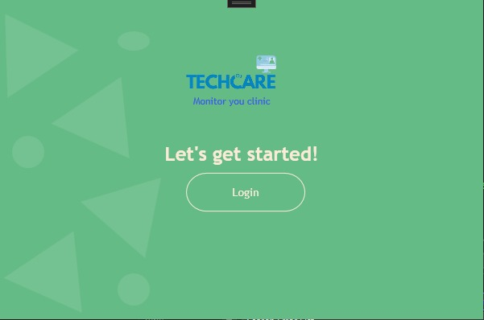***Results& Discussion**

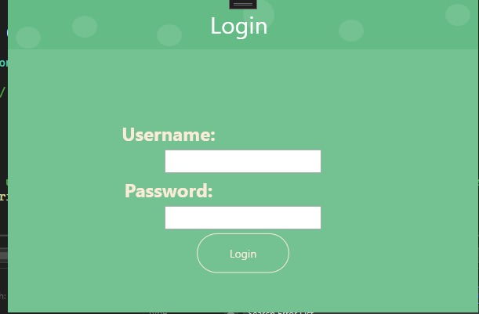*Figure 03: System Home*

*Figure04: Login page*

*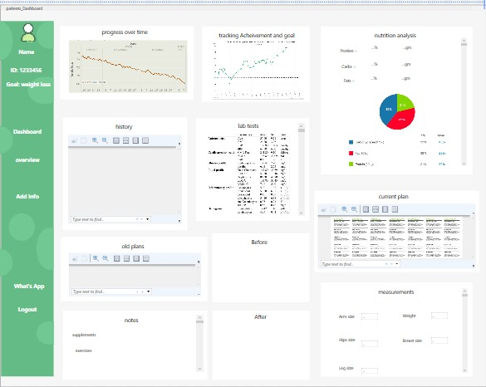Figure05: Patient data*

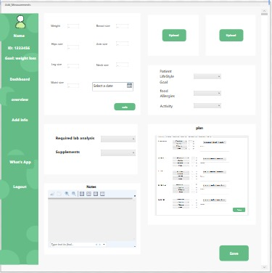

*Figure06: Patient Measurements*

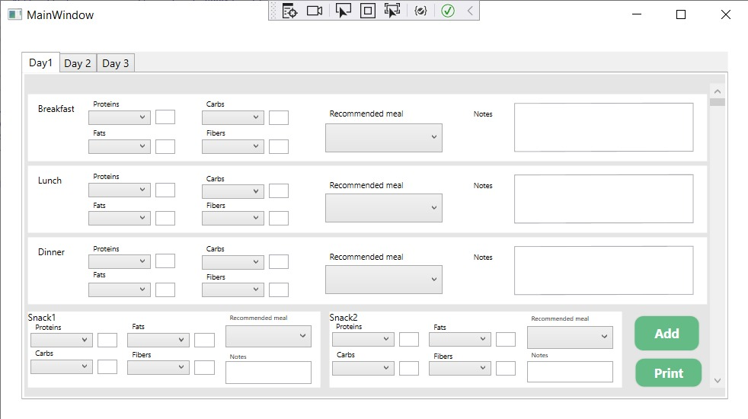

*Figure07: Diet plan*

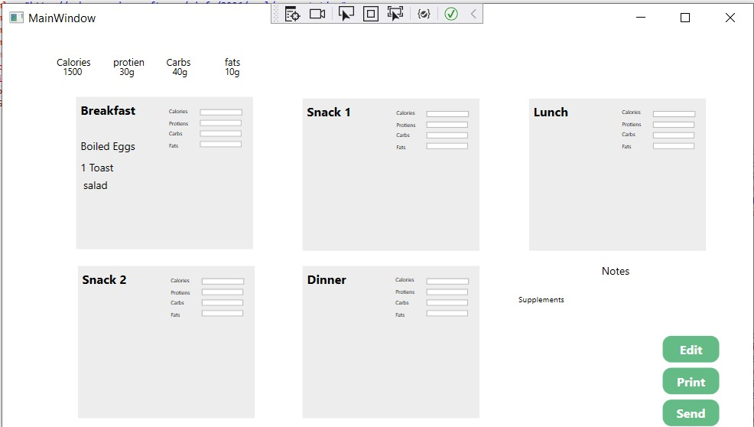

*Figure08: Meals*

**Recipient Views:**

4. Conclusion

Our nutrition and physiotherapy clinic management system application stands to significantly benefit both patients and healthcare providers alike. By streamlining the myriad tasks involved in clinic management, our application offers a user-friendly interface that simplifies operations. With a comprehensive database design for the system's back-end, we ensure efficient storage and retrieval of patient data, enabling healthcare providers to make informed decisions. On the front-end, users can easily navigate features such as viewing dashboards, scheduling appointments, and generating reports, all while accessing relevant resources and receiving guidance through the application's functionality. Moreover, our presentation of the completed application to clinic executives ensures alignment with their requirements and preferences, while seamless integration with the database via simple MySQL queries ensures smooth data management and retrieval. Overall, our project delivers a cohesive solution that supports essential clinic operations, enhances patient care, and improves efficiency in nutrition and physiotherapy clinic settings.

5. **Acknowledgments**

The nutrition and physiotherapy clinic management system aims to track various data related to patient health and treatment outcomes, enabling effective management of nutrition and physiotherapy services. This includes recording patient health metrics, dietary habits, exercise routines, treatment plans, and progress over time. Additionally, the system supports user operations such as appointment scheduling, patient management, and report generation. Proposed algorithms focus on automating tasks related to treatment planning, progress tracking, and outcome evaluation in nutrition and physiotherapy. Proficiency in using software tools like Visual Studio to develop applications connected with databases is crucial for designing a user-friendly and efficient nutrition and physiotherapy clinic management system.

6. Future plan & Suggestions

For future work and suggestions, we envision enhancing our nutrition and physiotherapy clinic management system to adapt to evolving trends and technologies in healthcare. With advancements in nutrition science and physiotherapy techniques, our system can incorporate more robust features aimed at improving patient care and treatment outcomes. This includes leveraging artificial intelligence (AI) technologies to develop innovative solutions for screening, diagnosing, and treating various health conditions related to nutrition and physiotherapy. AI-based devices can be integrated with our system to analyze patient data, such as dietary habits and exercise patterns, to provide personalized recommendations and early detection of health issues. Additionally, we plan to implement image assessment capabilities within our application, allowing for faster and more accurate evaluation of patient progress and treatment effectiveness. By continually updating and refining our technology, we aim to support healthcare providers in delivering comprehensive and effective nutrition and physiotherapy services to patients.

**7. References**

Cave, D., Abbey, K., & Capra, S. (2023). The challenges facing residential aged care homes to participate in quality food and nutrition research. *Journal of Human Nutrition and Dietetics*. <https://onlinelibrary.wiley.com/doi/full/10.1111/jhn.13154>

Singh, N. (2008). Computerized information systems for managing food and nutrition services. *Managing Food and Nutrition Services: For the Culinary, Hospitality, and Nutrition Professions*, 275. <https://books.google.com.eg/books?hl=en&lr=&id=S1EfC9rouzgC&oi=fnd&pg=PA275&dq=nutrition+clinic+management+system+desktop&ots=JZ_FBa1yzw&sig=o2wTa3KIQFK0_kusjjeXkV0WJBo&redir_esc=y#v=onepage&q=nutrition%20clinic%20management%20system%20desktop&f=false>

Tee, E. K., & Abdullah, N. (2023). Clinic Management System. *Applied Information Technology And Computer Science*, *4*(2), 1946-1965. <https://publisher.uthm.edu.my/periodicals/index.php/aitcs/article/view/11923>